# CS2111 - Web Application Development Midterm

**Fall 2021**

**Task 1:**

Your first task is to write the HTML and CSS code necessary to recreate the following appearance on-screen.

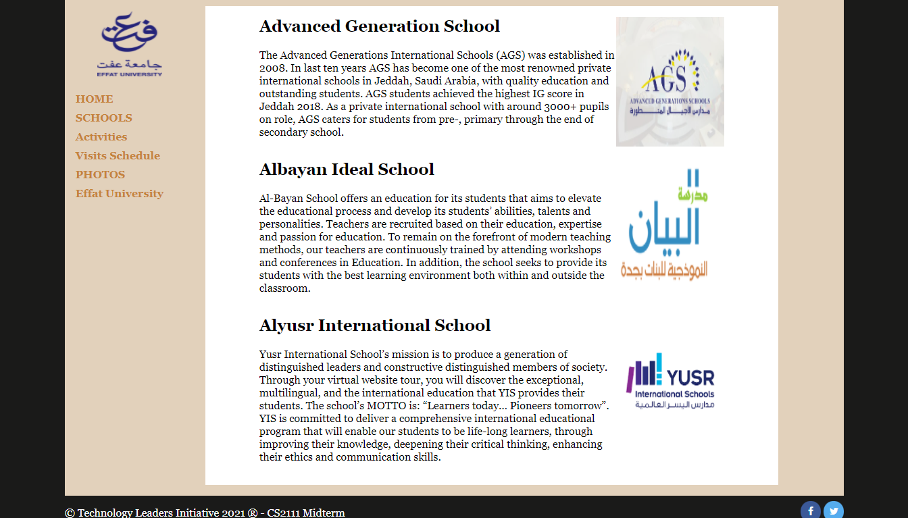

Most of the HTML code is given to you. The only change you may make to the provided HTML code is that you may add any number of div and span/containers (header, article, footer, etc) elements, possibly with id and/or class attributes, as targets for CSS styling. Write valid code that would pass the W3C validators. Below are some guidelines to help you out:

* Text on the page uses the “Georgia” font. The area around the outside of the page has a nearly-black color of #1A1A19.
* The overall page area has a background colored #E2D1BB. It is centered within the page and is 90% wide.
* The left sidebar has a logo in it, which should be centered within the column. The list of links in the left column are bolded, have no bullets or underlines, have a line height of 1.75em, and are colored #C5833B. The sidebar's content is 10em wide.
* The central content area has a white background color. Its content is 45em wide. Additionally, there is 4em of horizontal space on either side separating the content from the edges of the area.
* Surrounding each of the columns is 1em of space on all sides.
* Each news story on the page has an image that hovers to the right of other content, which wraps around it as necessary. There is 1em blank space around stories on all sides. No two stories should "collide" together; each story should be large enough on the page to fit its content.
* I have created the social media icons in the footer with the help of this tutorial: <https://www.w3schools.com/howto/howto_css_social_media_buttons.asp>

**Task 2:**

In this task, you need to create schedule.html page. Make your own design for the contents of this web page which shows the list of upcoming school visits. It should have a header and a table with the following columns: School Name, Date, Time, No. of Attendees, and Supervisor Name. The page should have left navigation menu like index.html.

**Good Luck**